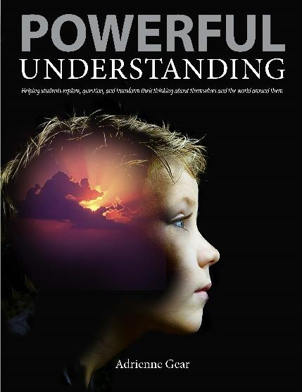
Powerful Understanding
Helping students explore, question and
transform their understanding of themselves,
others and the world.

Adrienne Gear Audience: K-9 School teams encouraged
to attend!

We are excited to have Adrienne Gear in our district to share ideas from her new book “Powerful Understanding.” In this session, she will explain the “Powerful Thinking” model and how it can be used to help students read, connect and reflect to deepen their understanding of themselves, others and the world. Adrienne’s new book explores effective ways to build social-emotional skills as well as promoting critical thinking – two important core competencies of our new curriculum. For those familiar with the Adrienne’s Reading Power strategies, you will see how she has integrated them into this model to extend and deepen learning. Adrienne will spend the first part of this workshop revisiting some of the key concepts of Reading Power and later, show how she took this foundation of “deep understanding of text” to “deep understanding of learning”. Adrienne will share lessons and student samples and, as always, you will come away with a list of great new anchor books! Come to this session and leave inspired and ready to teach your students to think critically and reflectively AND be confident, compassionate and caring citizens! It would be great to have school teams come out and join us for this important session! See registration details below.

Date: January 25, 2019
Time: 8:15 (coffee) 8:30 am-1:30 pm
Location: North Peace Cultural Centre
Please confirm your attendance with cstones@prn.bc.ca by January 21, 2019.
Questions can be directed to Charmaine Chretien @ cchretien@prn.bc.ca

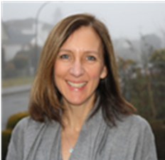
Adrienne Gear has been a teacher with the Vancouver School Board for over 25 years. She has worked as a classroom teacher, teacher librarian and district Literacy Mentor. She continues to teach part time, as well as provide professional workshops, demonstration lessons and leadership sessions to schools and districts throughout the province, country, and internationally. Adrienne is the author of five other books: Reading Power-Revised and Expanded (Pembroke, 2015) Nonfiction Reading Power (Pembroke, 2008), Writing Power (Pembroke, 2011), Nonfiction Writing Power (Pembroke, 2014), and Powerful Readers for Secondary Students (2016). Her books have been translated into French, Swedish, Danish, and Chinese.

Copies of Adrienne’s new book will be available to purchase at the workshop. ($27.50 - cash, check or credit)

