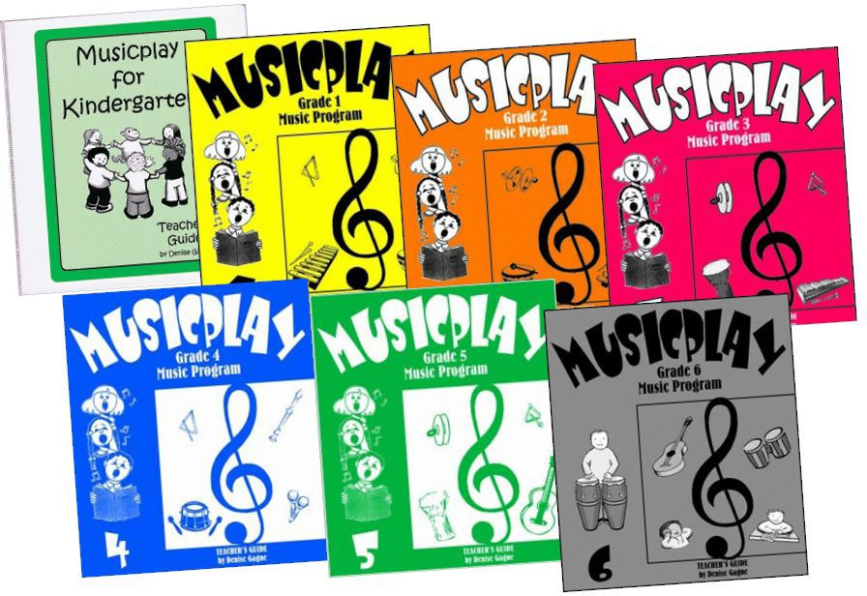

What should I do with all these music books and instruments?!?!?!?!?
.... And how do I read music?

Who: All K-6 teachers, EAs & Administrators!
When: January 24 Pro-D 9am-3pm
Where: Ma Murray Music Room

If you want to come, let Sabrina Brooks sbrooks@prn.bc.ca know so she can plan, or just show up. Sabrina has been teaching music from kindergarten all the way up to adult band for the last 10 years. All welcome.

